DRUMBEATER
Manning River Dragon Boat Club Newsletter
www.mrdbc.com.au
March 2015
No Paddling

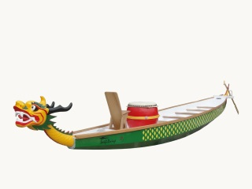
Due to the power boat races the Manning River is closed from 8.00 am Friday 3 April till 5.00 pm Sunday 4 April. So there will NO training on Friday or Saturday.
There will be NO Paddling on Saturday 25 April

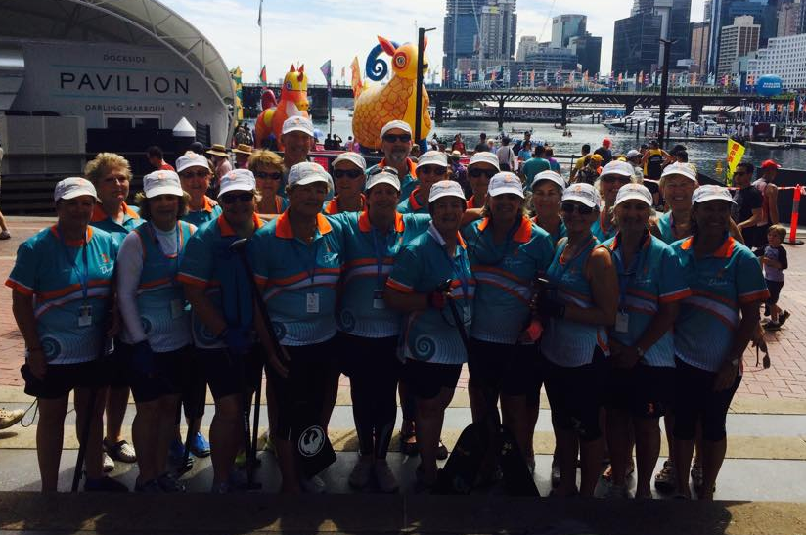
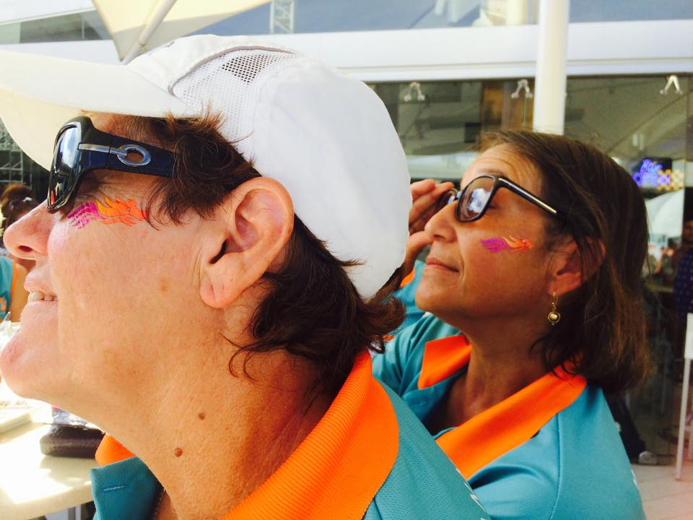
A word from our captain Jennifer
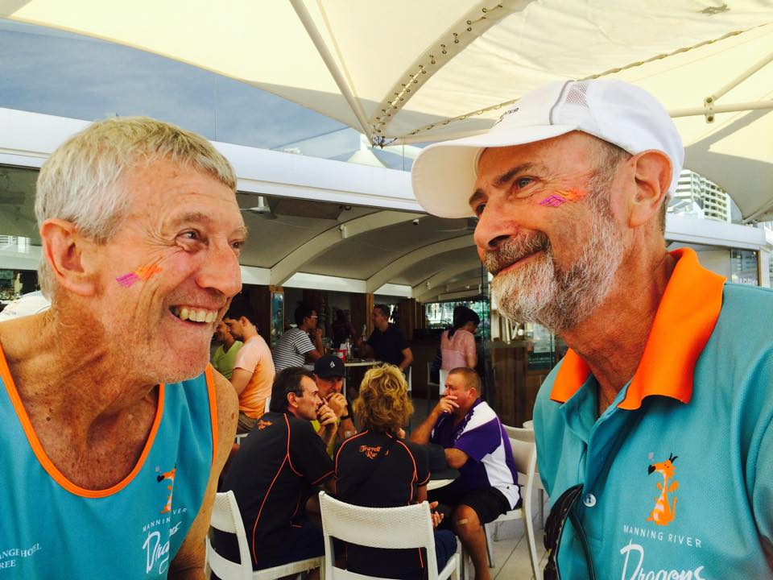
We had 22 women paddlers and two men attend the CNY regatta at Darling harbour on Saturday 28th February 2015.
We were in the Masters Women, up against women over 40years. In this category there were another 17 teams. The Masters Women had 2 races. In the first race we came third and the second race we came four. Just missing out making the final buy one second. Well done girls.
Our two men combined with the north coast waratahs. They had lots of paddles. Well done boys.
The crew had a great time of bonding together with lots of laughter. I wouldn’t miss this event, Ever. I would encourage others to attend.
The two Denise’s who have never been to CNY are now thoroughly addicted to the whole Dragon Boat scene.

DATES FOR THE DIARY
Friday 3 April | NO PADDLING | Manning River
Saturday 4 April | NO PADDLING | Manning River
Friday 17 April | Due date payment Urunga Regatta
Tuesday 21 April | Committee Meeting
Saturday 25 April | ANZAC DAY NO PADDLING
Sat & Sun 2-3 May | Urunga Regatta | Urunga
Happy Birthday to these Manning Dragons –
In March – Maureen Pratten 27th, John Roetman 28th

April –Demi Fox 12th, Denise Smith21st, Jennifer Schubert 27th,

Reminder of the month
Urunga Regatta names on the web site now so teams can be organised.

Expression of interest

Mel Cantwell is willing to travel to the Northern region pending enough participants to undertake the AusDBF Officials Course.

Depending on where the majority of participants are, she will present from there (eg Coffs, Port, Grafton etc). If there were enough, Mel has offered to undertake a Northern and Southern Session.

At this stage DBNSW is offering the Officials Course to us for free – so it is worth getting those passionate about the sport, those willing to learn, and those willing to travel to regional, State and National regattas to undertake it. Please let either me or Trish know if you are interested so were can forward your names to the northern region.
Manning River Dragon Boat Club Committee
President- Trish Paff, Vic President- Mary Chapman, Secretary- Anne Williams, Treasurer- Rhonda Blanch
Members Representatives- Alex Glencross, Ruth Coleman, Sheryl Humphries
Registrar- Cath Stenchion

